HOTEL PASEO DEL ARTE
HOTEL BOOKING FORM
CONFERENCIA POLIS

NAME:__________________________________________________________

Arrival Date: ________________
Departure Date:______________ Nº of nights:________

Double for single use room Double/ twin room

The payment will be directly at the hotel. We need a credit card to guarantee the reservation.

PAYMENT:

- CREDIT CARD:

VISA MASTERCARD AMERICAN EXPRESS OTHER:________________________________________

Credit Card Number:

Expiry Date: _ _ / _ _

The holder authorizes to charge in the credit card provided, amount for one night of stay as penalty in case of no show or cancellation 48 hrs before arrival.

SPECIAL REMARKS:

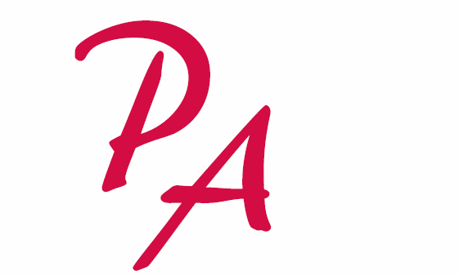
___________________________________________________________________________________________________________________________________________________________________________________________________________________________________________________________________________________________________________________________
C/ Atocha, 123
28012 MADRID
Tlfno: 912 984 800
Fax: 912 984 850



