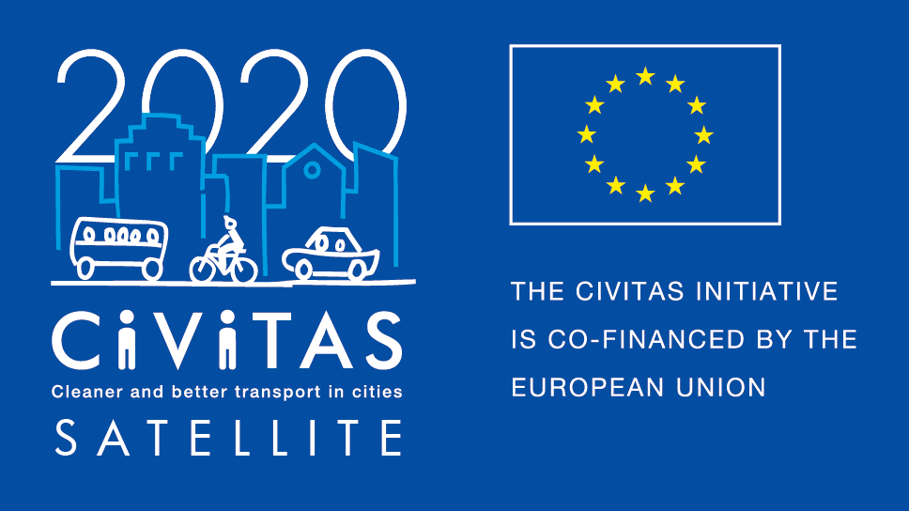
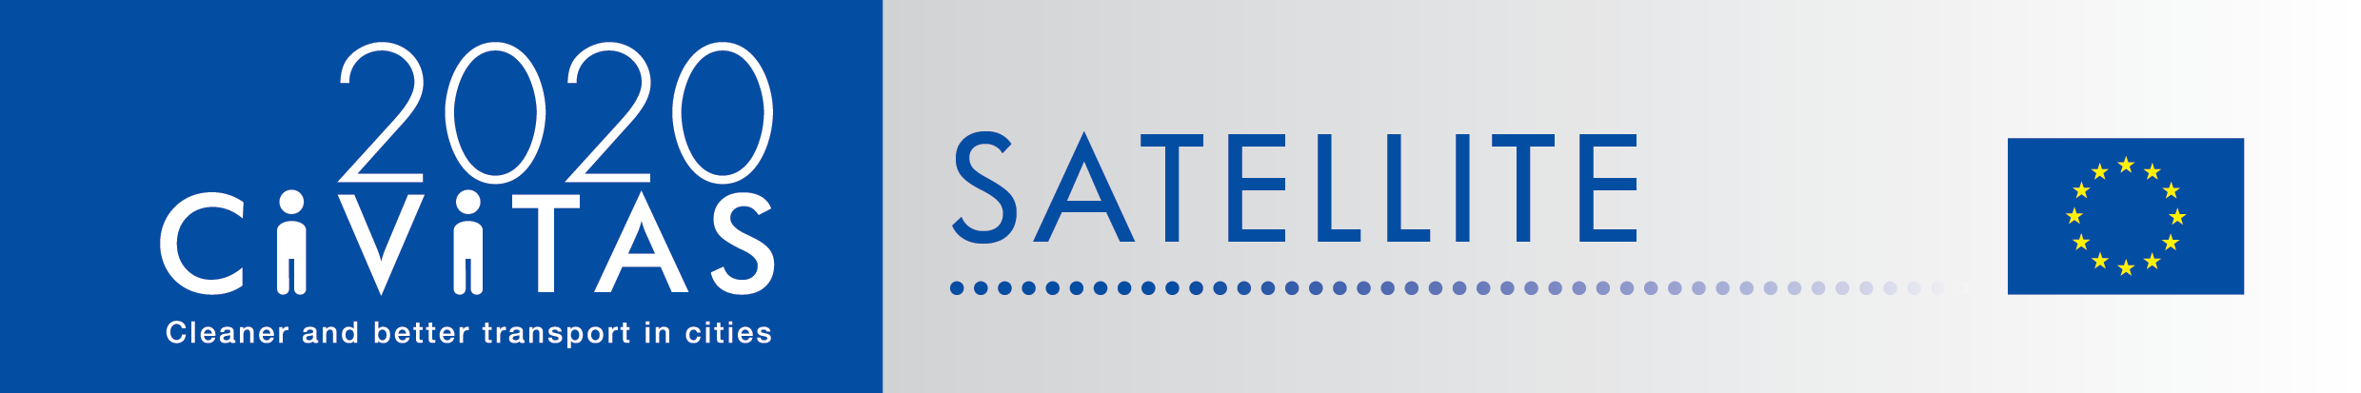
w

SATELLITE application form for visiting cities
Form B

Project Acronym: | CIVITAS SATELLITE
Full Title: Support Action Towards Evaluation, Learning, Local Innovation, Transfer and Excellence
Grant Agreement No.: | 713813
Deadline for application: 7th November 2016
Contact person: melanie.leroy@eurocities.eu

CIVITAS SATELLITE peer-to-peer activities in a nutshell

CIVITAS SATELLITE is an initiative designed to support cities in gaining better access to innovative solutions and to address transport challenges by applying exchange mechanisms for transfer and take-up.
Between 2017 and 2020, SATELLITE will organise at least 20 visits, in the form of work placements and study visits, for city representatives willing to learn from each other and to exchange extensively with each other.
Participants for these peer-to-peer visits will be selected each year through calls for expression of interest.

This form is for cities willing to take part to a work placement or a study visit (form B)

- What is a work placement?
CIVITAS SATELLITE work placements offer transport professionals hands-on learning experience in another European city that leads in a specific area of sustainable urban mobility. These 3 day placements will focus on a concrete topic and respond to a local challenge faced by the applicant/visiting city. The main objective is to transfer practical knowledge and expertise from the host city to help achieve a specific objective. Financial support is available to cover travel and accommodation costs.

- What is a study visit?
CIVITAS SATELLITE study visits offer the opportunity for up to 10 city representatives to travel to another European city facing similar challenges in sustainable urban mobility to learn about possible solutions and best practices. These 2,5-3 day study visit will be tailored to the needs of the participating cities and take an interactive approach, to facilitate in-depth exchange, and strengthen cooperation. City representatives will benefit from financial support covering travel and accommodation costs.

- Why join CIVITAS SATELLITE peer-to-peer programme?
If you are a visiting city, you will …
- Have hands-on experience in another city,
- Have the opportunity to exchange on a one-to-one basis with leading peers,
- Be promoted on the CIVITAS website and European-wide media outlets as a city committed to sustainable urban mobility.
- Be offered speaker slots at European level events.

- What will CIVITAS SATELLITE provide in terms of funding and support?
If you are a visiting city, you will…
- Financial support up to €700 for travel and accommodation.
- Support in the organisation and the follow-up of the visit.

- What will be the tasks of cities involved?
If you are a visiting city, you will…
- Define a detailed request for learning, followed by an online pre-visit survey (for the study visit).
- Identify a local challenge faced by their city (for work placement)
- Liaise with the SATELLITE team to agree on the objectives of the visit
- Write a short impact report describing new skills acquired
- Send all documents required for the reimbursement of costs

- Apply!
Do you want take part to CIVITAS SATELLITE peer-to-peer exchanges? Please fill in the application form by 7th November 2016 and send it back to melanie.leroy@eurocities.eu
Please note that there are 2 different forms: one for the host cities (form A) and one for the visiting cities (form B) below, you can apply both as host and as visitor!

- Contact person:
If you have any questions, please contact Melanie Leroy: melanie.leroy@eurocities.eu (+32 2 552 0881)

Form B - CIVITAS SATELLITE Call for visiting cities

- Fundamental information
Name of the city & Country
Structure & size | ☐ City  ☐ Metropolitan area  Population:
What kind of visit do you want to attend? | ☐ Work placement  ☐ Study visit
Are you member of the CIVITAS Community? | ☐ CIVITAS demonstration city  ☐ CIVITAS Forum network city  ☐ CIVINET member city  ☐ IA or RIA project partner city  ☐ None
Has your city been awarded an award for its work on sustainable mobility?  If yes, which one? | ☐ CIVITAS award  ☐ EUROPEANMOBILITYWEEK award  ☐ SUMPs award  ☐ Other (please specify)  ☐ My city has applied or has been short listed but not selected  ☐ None
Do you have recent experience of peer-to-peer exchange?  If yes please specify | ☐ Yes (Please specify below)  ☐ No

- Preparing the visit
What are the main reason(s) why you want to take part to a CIVITAS peer-to-peer visit?
Which theme(s) do you want to learn about during your visit? | ☐ Clean fuels and vehicles  ☐ Collective passenger transport  ☐ Car-independent lifestyles  ☐ Demand management strategies  ☐ Integrated planning  ☐ Mobility Management  ☐ Public involvement  ☐ Safety and security  ☐ Transport Telematics  ☐ Urban freight logistics  ☐ Other: (please specify)
Which challenge from your city do you plan to present to your host city?
How do you plan to do this?
Which key local/regional decision makers, project managers and/or stakeholders would you like to meet during your visit? Why?
Will you communicate about this visit? If yes how?

- Practicalities and joining instructions
Contact person(s) for the organisation of the visit | Name:  Position:  Telephone:  Email:  Address: | Name:  Position:  Telephone:  Email:  Address:
Other questions

Final declaration
I have the pleasure to inform you that the city of name of the city/region supports the participation of its staff in the CIVITAS SATELLITE initiative in [2017].

Place
Click here to enter a date.
Name
Position
City/region

