TIDE WORKSHOP FOR NON-MOTORISED TRANSPORT
Donostia / San Sebastián, SPAIN
22-23 May 2014
1. Timings (for booking travel)
Day 1 – Thursday 22 nd May 2014 14:00 to 18:00.
Day 2 – Friday 23th May 2014 9:00 to 14:00.
- Venue
The meeting will take place at Donostia / San Sebastián.
- Location
The conference will be held in a central location with easy access from mayor hotels in the city.
4. How to get to venue/meeting point?
By plane
There are three airports near San Sebastian:

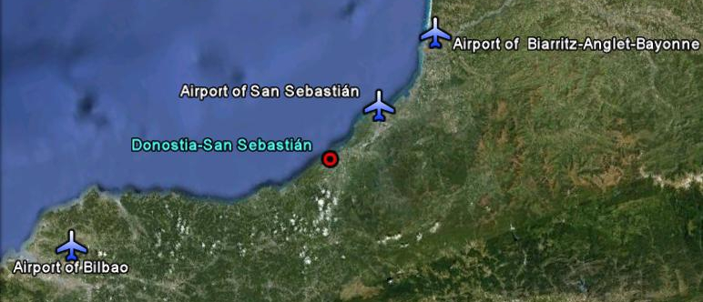

 Airport of San Sebastian (Hondarribia)

This airport is settled in Hondarribia, at a distance of 20 km to the center of the city, and has connections with Barcelona and Madrid.

http://www.iberia.com Iberia has direct flight with Madrid and Barcelona and these cities have connections with many European cities.

To get to San Sebastian there are two options:

- Public Transport
E21 Airport – San Sebastian direct (by motorway) Bus line. There is a bus every hour and the travel time is 29 mins. 2.30€

- Taxi
The service is about 30 € and lasts 20 minutes.

Airport of Bilbao (Loiu)

The airport of Bilbao is about 100km from San Sebastian, and it has direct connections with the following cities in Europe:

- Amsterdan/Schipol (Netherlands)
- Barcelona (Spain)
- Brussels (Belgium)
- Dublin
- Düsseldorf (Germany)
- Frankfurt (Germany)
- Lisbon (Portugal)
- London Heathrow (United Kingdom)
- London Stansted (United Kingdom)
- Madrid (Spain)
- Manchester (United Kingdom)
- Munich (Germany)
- Paris Charles de Gaulle (France)
- Paris Orly (France)
- Rome Fumicino (Italy)
- Stuttgart (Germany)

PESA Company offers a bus service to San Sebastian every hour, with direct route from the airport to the bus station in San Sebastian. The timetable is available here. The travel time is 75 minutes and costs 16.50€.

And if you want to get to San Sebastian by taxi it costs 140 € and lasts 60 minutes.

Hotels recommended for this meeting and venue of the meeting are at a walking distance of bus station (15-20’).

To reach the city center from the bus stop that is next to the bus station, you could take the following bus lines:

28- AMARA-HOSPITALES
26- AMARA- MARTUTENE
21- MUTUALIDADES-ANOETA

Airport of Biarritz-Anglet-Bayonne

This airport is located in France, 40 km from San Sebastian and has direct connections with the following cities:

- Brussels (Belgium)
- Helsinki
- Copenhagen (Denmark)
- Oslo
- Dublín (Ireland)
- Geneva (Switzerland)
- Lille (France)
- London (United Kingdom)
- Lyon (France)
- Marseille (France)
- Nice (France)
- Paris (France)
- Stockholm (Sweden)
- Strasbourg (France)

You can see the different modes of transport available from Biarritz airport here.

By train

Situated right in the centre of the city, San Sebastian's train station, known as the Estación del Norte (Northern Station), is connected to a large number of Spanish cities, including Madrid and Barcelona, and also international destinations, such as Paris and Lisbon.

There is also a narrow-gauge railway that runs to Bilbao and different Basque coastal towns plus a line on which a train called the "Topo" runs to Hendaye Gare in France (30 min) where the TGV from Paris arrives.

- http://www.renfe.es
- http://www.euskotren.es
- http://www.sncf.com

By bus

San Sebastian has a sizeable bus station that connects the city with others throughout Spain and part of the European continent. It is situated in Arquitectos Kortazar street, in the Amara district, 5 minutes from the city centre.
Main bus lines companies from San Sebastian:

- Eurolines
- Alsa
- Vibasa
- Pesa
- Conda

- Accomodation
A wide range of hotels are available in central Donostia / San Sebastian. All are within easy walking distance of the station and venues.

Hotels

Participants are responsible for booking their own hotels.

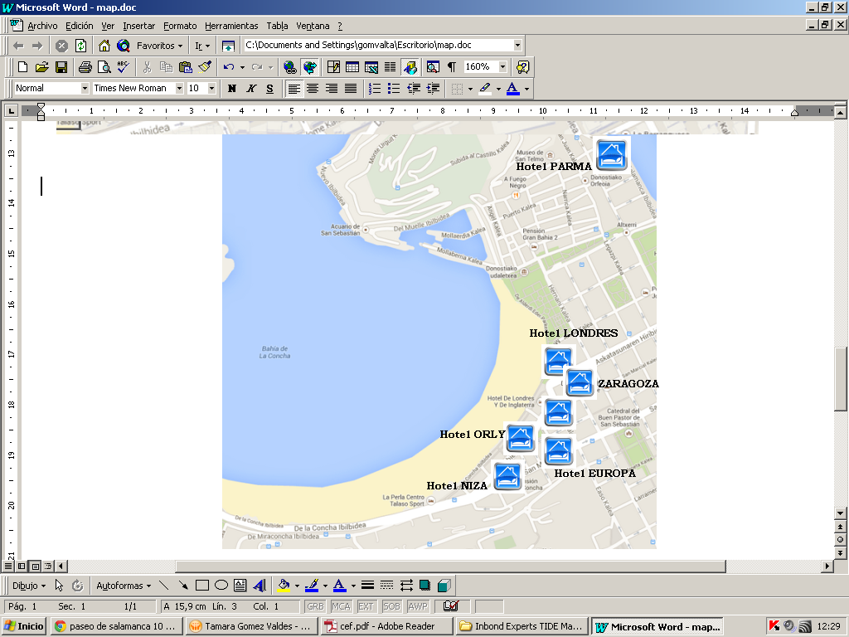

Hotel LONDRES 4*
Zubieta, 2

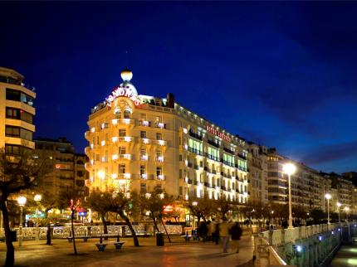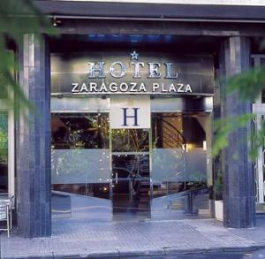

Hotel ORLY 4*
Plaza de Zaragoza, 4

Hotel NIZA 3*
Zubieta, 56

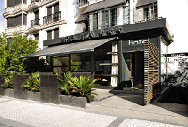

Hotel EUROPA 3*
San Martin, 52

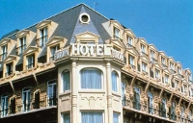

Hotel ZARAGOZA 1*
Plaza de Zaragoza, 3

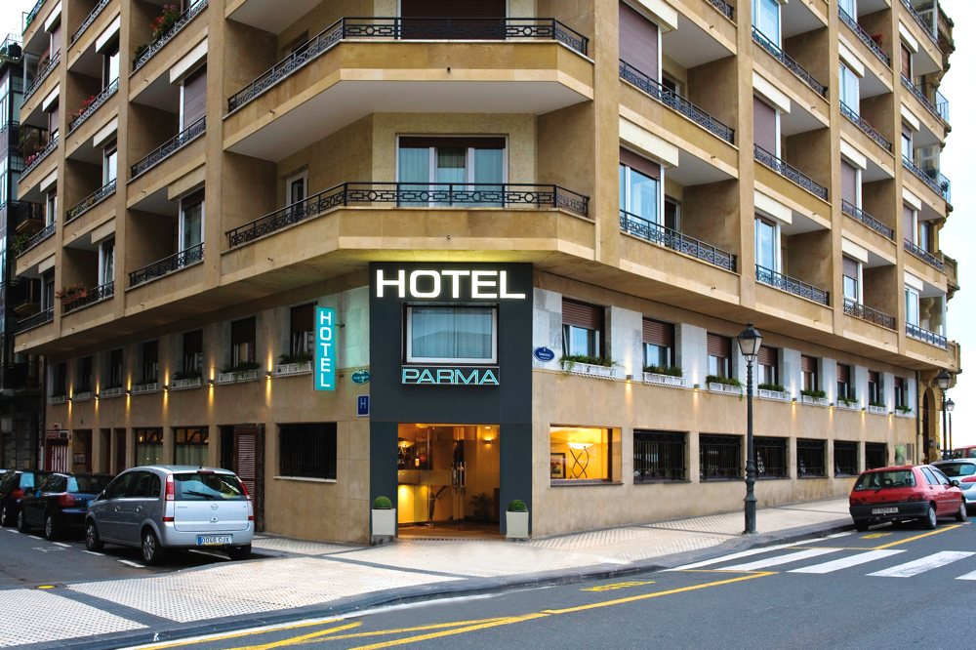

Hotel PARMA 2*
Paseo de Salamanca,10

For further information: Donostia / San Sebastian Tourism website
Contact
For further information, please contact:
Donostia-San Sabastian: Fermín Echarte Peña - fermin_echarte@donostia.org - +34 943481449
Donostia-San Sabastian: Iñaki Baro – Inaki_Baro@donostia.org - +34 943 48 15 91
Donostia-San Sabastian: Tamara Gómez- Tamara_Gomez@donostia.org - +34 943 48 28 09
For further information about TIDEplease see: http://www.tide-innovation.eu/en/

